
Music Curriculum Intent
At WPA, we aim to ensure that Music is an enjoyable learning experience where children have the opportunity to learn and play a range of songs, composition and instruments, as well as building their confidence whilst performing in front of their peers and a wider audience. Music is a form of expression that is celebrated and we aim for our children to become inspired to develop a love of music and to develop their talents as a musician, therefore increasing their self-confidence, creativity and sense of achievement.

Implementation
We use Charanga Musical School online programme as a basis for our weekly music lessons to ensure high quality, enjoyable music provision with clear National Curriculum coverage across all year groups. The learning within each scheme is based on: Listening and Appraising; Musical Activities - creating and exploring; and Singing and Performing.

Next to the discreet music lessons, singing and other musical activities are used to enrich subjects and other parts of the curriculum. Assemblies and plays also provide an opportunity to practise singing. We hold a weekly singing assembly with our music lead who ensures children learn and develop performance and singing skills. Pupils will also be taught to play a variety of instruments musically and encouraged to play together in ensemble groups. We encourage listening to a wide range of music with concentration and understanding and background music can be heard daily around school. In different year groups, we also design opportunities for children to sing/ perform in groups e.g. Songmaker at Dorchester cathedral.

All learning starts with revisiting prior knowledge and making meaningful connections. Charanga ensures planning demonstrates this. Staff model explicitly the subject-specific vocabulary, knowledge and skills relevant to the learning to allow them to integrate new knowledge into larger concepts. Music assessment is ongoing throughout the curriculum themes. Summative assessment is completed at the end of each theme to inform leaders of the improvements or skills that need to be developed further.

Impact
Pupil voice is used to enable leaders to assess the impact of the Music curriculum and whether children know and remember more. Pupil performances in class and throughout the school show the high standards expected and are celebrated via the school website and weekly newsletter.

 | Autumn 1 | Autumn 2 | Spring 1 | Spring 2 | Summer 1 | Summer 2
EYFS | Me! | My stories | Everyone | Our World | Big Bear Funk | Reflect, Rewind, Reply
Year 1 | Hey you! | Rhythm | In the Groove | Round and Round | Your imagination | Reflect, Rewind, Reply
Year 2 | Hands Feet Heart | Ho Ho Ho | I wanna play in a band | Zootime | Friendship Song | Reflect, Rewind, Reply
Year 3 | Let your spirit fly | Glockenspiel stage 1 | Three little birds | The dragon song | Bringing us together | Reflect, Rewind, Reply
Year 4 | Mamma Mia | Glockenspiel stage 2 | Stop | Lean on Me | Blackbird | Reflect, Rewind, Reply
Year 5 | Living on a prayer | Classroom Jazz 1 | Make you feel my love | The fresh prince | Dancing in the street | Reflect, Rewind, Reply
Year 6 | Happy | Classroom Jazz 2 | A New Year Carol | You’ve got a firend | Music and Me | Reflect, Rewind, Reply

Music  Outcomes | See individual year group knowledge and skills progression documents attached for full information  EYFS  - Sing a range of well-known nursery rhymes and songs;  - Perform songs, rhymes, poems and stories with others, and – when appropriate – try to move in time with music.  KS1  Pupils should be taught to:  - use their voices expressively and creatively by singing songs and speaking chants and rhymes  - play tuned and untuned instruments musically  - listen with concentration and understanding to a range of high-quality live and recorded Music  - experiment with, create, select and combine sounds using the inter-related dimensions of music  KS2  Pupils should be taught to sing and play musically with increasing confidence and control. They should develop an understanding of musical composition, organising and manipulating ideas within musical structures and reproducing sounds from aural memory.  Pupils should be taught to:  - play and perform in solo and ensemble contexts, using their voices and playing musical instruments with increasing accuracy, fluency, control and expression  - improvise and compose music for a range of purposes using the inter-related dimensions of music  - listen with attention to detail and recall sounds with increasing aural memory  - use and understand staff and other musical notations  - appreciate and understand a wide range of high-quality live and recorded music drawn from different traditions and from great composers and musicians  - develop an understanding of the history of music

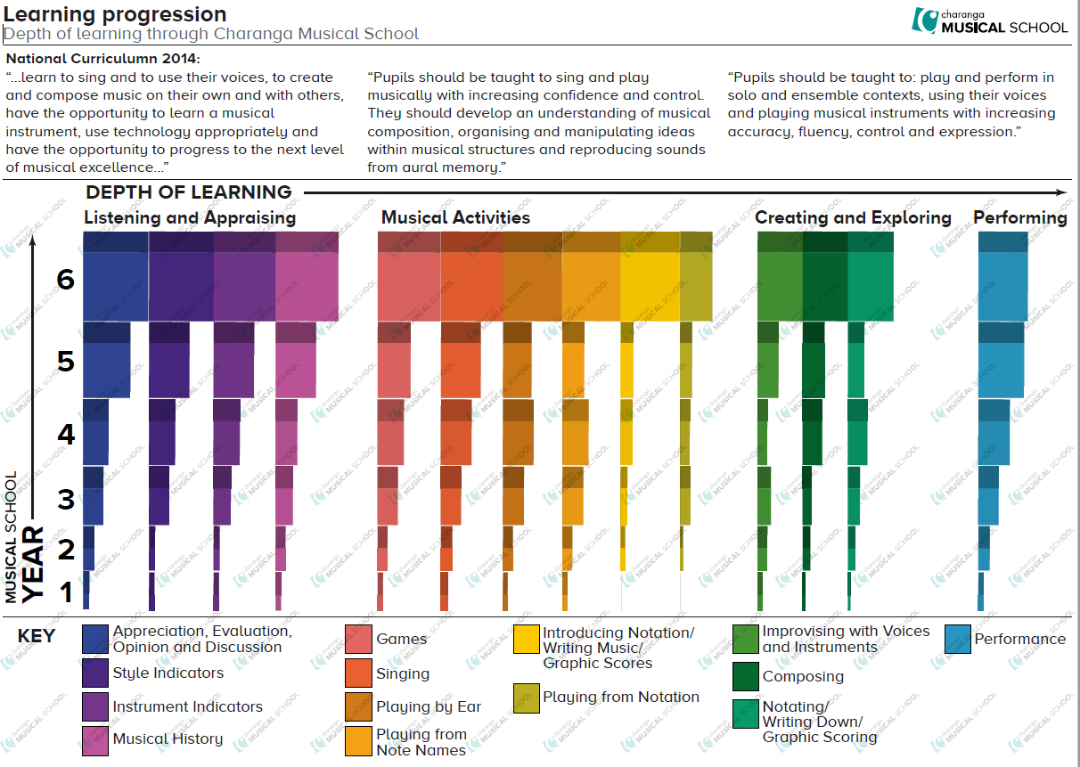
Appendix – Deeper Thinking Questions
This list is not exhaustive and provides examples of the types of questions which could be asked.
Can you…:
Perform the melody?
Perform the piano part?
Perform the accompaniment part?
Perform the bass part?
As a group, recreate…?
Show me the rhythm before… and after…?
Show me how… changes?
Show me a similar…?
Show me the original/feature of…?
Using the correct instrument, show me the chords of this song?
Show me the part that… performed?
Show me what would happen if…?
Shoe me the changes that you made…?
Show me the most important rhythm/melody?
Show me the least effective rhythm/melody?
Make improvements to...?

