WPA MFL (Spanish) Overview
Intent and Implementation
Teaching a modern foreign language is a compulsory subject at Key Stage 2 (Year 3 upwards). However, we start our pupils experiences of Spanish and other languages in Reception by using fun activities and games and through our role play area. We start weekly Spanish lessons from Year 1 to ensure the children gain the necessary skills and enjoyment of new languages and cultures. At WPA, we teach a weekly MFL session of 20 minutes in KS1 and 30 - 45 minute sessions across Years 3-6. Our lessons include engaging activities such as songs, games and chances to respond in speech and writing through regular conversation and exposure. Our lessons ensure our children revise the vocab they have learnt and revision is planned in across the years to enable children to confidently recall the language.

At WPA, our pupils are taught to:
- Listen attentively to spoken language and show understanding by joining in and responding
- Engage in conversations, ask and answer questions, express opinions and respond to those of others, and seek clarification and help.
- Read carefully and show understanding of words, phrases and simple writing.
- Broaden their vocabulary and develop their ability to understand new words that are introduced into familiar written material, including through using a dictionary.
- Write phrases from memory, and adapt these to create new sentences, expressing their ideas clearly.
- Describe people, pleases, things and actions in speech and writing.

We use Lightbulb languages resources to plan and sequence our lessons and ensure that each one builds on previous experiences.
Each KS2 unit includes a knowledge organiser which helps to support teachers and children to understand the new content and vocabulary (see examples below):
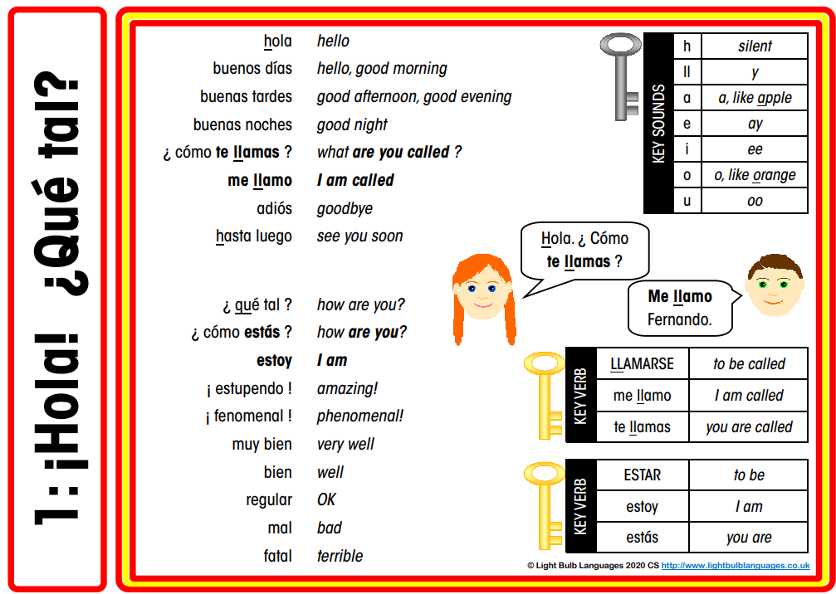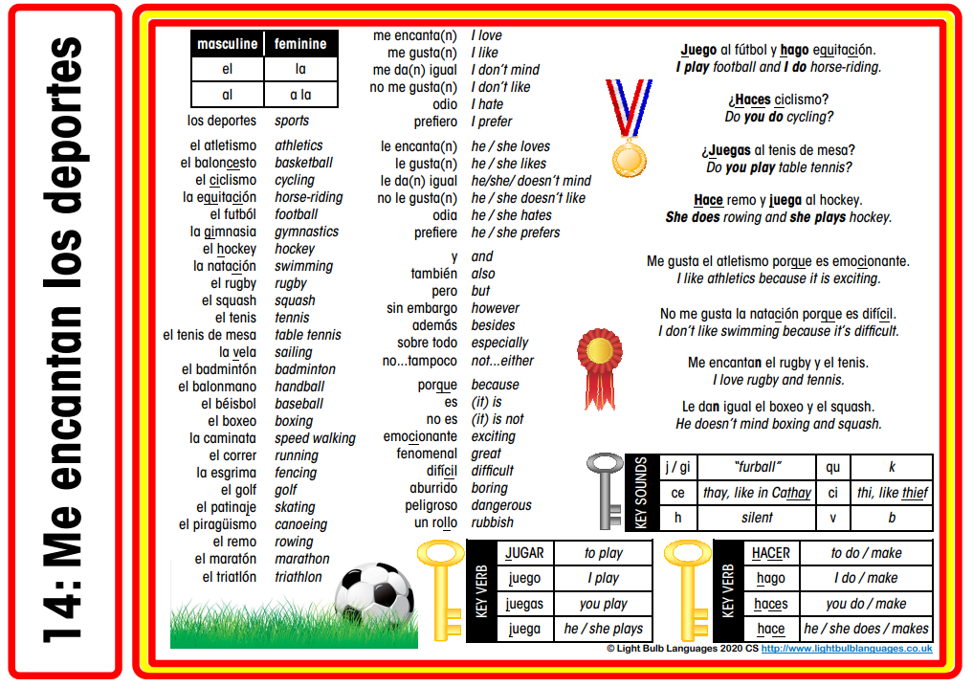

Our teaching and learning process:
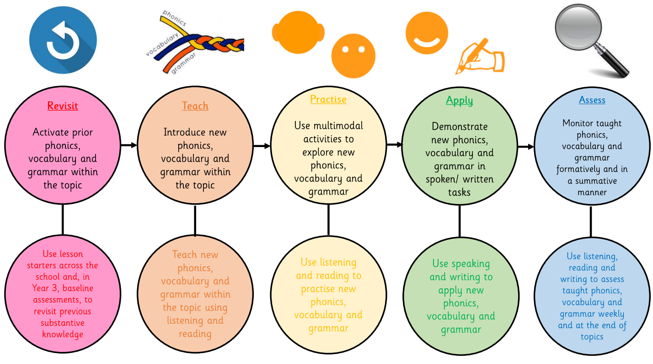

The three ‘pillars’ (threads) of a modern foreign language, such as Spanish, are phonics, vocabulary and grammar. Phonics are the sounds in Spanish, such as /v/ pronounced as ‘b’ and /ce/ pronounced like ’the’ in ‘therapy’. Vocabulary are the words, such as numbers from one to 39, and phrases, such as greetings like ‘Buenos días’. Grammar is the structures: the gender of nouns (masculine or feminine), singular and plural forms, adjectives (where they are placed in phrases and sentences and their agreement with nouns based on the gender of the noun) and the conjugation of key verbs (according to the subject in a sentence and based on tense).

These three threads are taught, practised, applied, assessed and revisited through four key components: listening, speaking, reading and writing. Listening involves showing understanding by joining in and responding, and linking the sound, spelling and meaning of vocabulary. Speaking involves asking and answering questions, expressing opinions, asking for clarification and help, speaking in sentences, and verbally describing people, places and things. Reading involves reading and comprehending phrases and simple texts, reading aloud with accurate pronunciation and using a dictionary. Writing involves writing phrases from memory, adapting phrases to create new sentences and, in writing, describing people, places and things. Listening is the input and speaking is the output of it while reading is the input and writing is the output of it.

WPA Long term Overview
Year group | Autumn |  | Spring |  | Summer
EYFS: Songs, rhymes and rhythms from different cultures and languages, with a focus on Spanish numbers and colours.
Year 1 | Greetings hello and goodbye  Numbers 1-6 |  | Saying “Yes and no” and “please and thank you”  Fruits and vegetables |  | Shapes and colours (4 of each)
Year 2 | Greetings and name  Numbers 1-10 |  | Numbers 0 – 15  Animals |  | Shapes and colours (revise and new) Putting colour and shape together e.g. un triangulo rojo
Year 3 | Recap greetings, giving name, asking for name and saying how you feel | Numbers to 15  Giving and asking for age | Colours and ser  Gender of singular nouns using equipment | Family – members, names and ages | Pets – names and ages  Recap shape, colour and phrases.  Colours, flags and consolidation of areas
Year 4 | Recap and numbers to 40  Wild animals and numbers of | Months  Days and dates | Singular foods and opinions | Plural foods and opinions | Weather | Compass points, towns and consolidation
Year 5 | Numbers and money | Describing planet | Bodies | Sports | Time and consolidation
Year 6 | Describing towns | Town activities | Transport and the verb to go | Countries language and nationality | Reponses to questions |  | Written responses and KS3 readiness

Context, grammar, vocabulary and phonics overview KS1
Term | Year group | Context | Objectives | Phonics and grammar | Vocabulary | Planning Activities and video link
Autumn | Y1 | Greetings - hello and goodbye | to greet and say goodbye to another person appropriately | h, ll, ñ, a, o | hola  buenos días  buenas tardes  buenas noches  hasta luego | https://www.youtube.com/watch?v=b8urKtX-0vQ  https://www.youtube.com/watch?v=CqN1ENPfaeQ  Introduce the key greetings from the vocabulary list.  Activities in Y1 folder
Autumn | Y1 | Numbers 1 - 6 | to count and recognise numbers from 0 to 6 | ce / ci / z, b/v, cu | uno  dos  tres  cuatro  cinco  seis | https://www.youtube.com/watch?v=ZstZbgQ-im8&list=PLgM5QBCeWdkKJ-dJeaw3mQMkM1eHfBQDA&index=3&t=308s  https://www.youtube.com/watch?v=7ikXOvJDRnw  Practise 1-6 and sing Uno dos tres  Hold number cards and Spanish numbers and get children to match them  T Shirt Worksheet in folder
Spring | Y1 | Saying “Yes and no” and “please and thank you” | to recognise and use please, thank you, yes and no in conversation |  | Si  No  Gracias  Por favor  uno  dos  tres  cuatro  cinco  seis | https://www.youtube.com/watch?v=hkIa0lUki6s&list= PLgM5QBCeWdkKwe7ebDnU0ZuYZW-MNKFpu&index=4  https://www.youtube.com/watch?v=yXoT-9dOpug&list=PLgM5QBCeWdkKwe7ebDnU0ZuYZW-MNKFpu&index=5  Learn yes, no, please and thank you by watching the videos and practising with a friend.  Several activities linked  Week 1 – videos and oral  Week 2 – recap and match Spanish to English (find a partner)  Week 3 – Numbers ‘Pitch Point’ Tacher holds up a number e.g. 6 and says dos. Children then say si por favor or no gracias. Carry out activity from folder  Week 4 – As above but with counting objects in Spanish and writing if it’s correct
Spring | Y1 | Fruits and vegetables | To name some common fruits and vegetables | Singular nouns | manzana  pera  naranja  ciruela  plátano  fresa  pepino  tomate  zanahoria  lechuga  judía | https://www.youtube.com/watch?v=pAmCg6g7Klw&list=PLgM5QBCeWdkKJ-dJeaw3mQMkM1eHfBQDA&index=6  https://www.youtube.com/watch?v=gXO8i3Tatg0&list=PLgM5QBCeWdkKJ-dJeaw3mQMkM1eHfBQDA&index=8  Introduce with flashcards and play flashcard games/ matching  Week 1 – video 1 and oral rehearsal  Week 2 – recap video 1 and draw a basket of fruits and label them in Spanish.  Week 3 – Share basket with friend and allow them to guess, in Spanish  Week 4 – Watch video 2 – adding foods. Children write a shopping list.
Summer | Y1 | Colours | To know colours in Spanish |  | rojo  azul  verde  amarillo  blanco  negro | https://www.youtube.com/watch?v=G1Dt5RtwDv8&list=PLgM5QBCeWdkKJ-dJeaw3mQMkM1eHfBQDA&index=11  https://www.youtube.com/watch?v=TD7I1cCzfTY&list=PLgM5QBCeWdkKwe7ebDnU0ZuYZW-MNKFpu&index=8  Week 1 - Watch video 1 and get the children to repeat the key colours. Hold up colour patches and children to I do-we do-you do  Week 2 – watch video 2, working on pronunciation. Introduce with flashcards, play flashcard games. Worksheets to colour. Re introduce the written word, colour sheet and put blocks in right order. Share with friend using oral words and children to recreate.  Week 3. Children create their own patterns . Share with friend to create  Worksheets in drive
Summer | Y1 | Shapes | To know shapes and colours in Spanish |  | círculo  cuadrado  triángulo  6+ colours | https://www.youtube.com/watch?v=r0sRREEYlYM  Week 1 – Watch video. Take shapes out of a bag. Name them in English and in Spanish.  Week 2 – Re watch video. Do worksheet of shape names – orally and written  Week 3 – recap colours and shapes. Worksheet of shapes and colours in sentences – orally first.  Week 4 – colours and numbers consolidation.
Autumn | Y2 | Greetings and name | To greet and say goodbye to another person appropriately  to say what their name is |  | Hola  buenos días buenas tardes buenas noches adiós hasta luego  me llamo | https://www.youtube.com/watch?v=nyfLGENmbCE&list=PLgM5QBCeWdkKwe7ebDnU0ZuYZW-MNKFpu&index=2&t=3s  Week 1 – assessment from Y1  Week 2 - Greet the children with hola and ensure they recognise what this means. Recap greetings from Year 1 e.g. buenos tardes  Week 3 – Watch the video and ask the children what their name is (in Spanish). Get them to say my name is ___. Me llamo ___. Ensure all can do it verbally before introducing the written words. Get them to explain how some of the sounds sound different e.g. ll makes the y sound.Link to our phonics lessons.  Week 4 – recap saying name verbally. Rewatch video. Put children in pairs and get them to say their name.
Autumn | Y2 | Numbers 1-10 | To be able to count from 1-10 |  | uno  dos  tres  cuatro  cinco  seis  siete  ocho  nueve  diez | https://www.youtube.com/watch?v=JDQkorzl6UQ&list=PLgM5QBCeWdkKwe7ebDnU0ZuYZW-MNKFpu&index=7  Watch the video and practise the numbers.  Each week, show flash cards or numbers of objects and get children to count them.  Introduce the written words and again discuss the phonics sounds.
Spring | Y2 | Animals | To able to name common animals |  | cocodrilo  mono  serpiente  águila  gato  elefante  topo  león  camello  perro  rana  jirafa  oso | https://www.youtube.com/watch?v=gKLgtn0cBSA&list=PLgM5QBCeWdkLNUbBIkg1QHDUQfl8FPrsU&index=5Read  Week 1 – watch video and say the animals, decide on an action for each one, clap the syllables  Week 2 – recap animals learnt last week and play a pairs game as a class.  Week 3 – Written task. Match up animals with their name
Spring | Y2 | Numbers 0 – 15 | to be able to count to 15 and recognise numbers to 15. |  | From Autumn +  Once  Doce  Trece  Catorce  Quince | https://www.youtube.com/watch?v=I6tAHmrsVuA&list=PLgM5QBCeWdkKwe7ebDnU0ZuYZW-MNKFpu&index=14  Watch the video clip and do lots of oral rehearsal  Carry out the activities
Summer | Y2 | Shapes and colours | To be able to name common shapes and colours  To be able to create phrases using common shapes and colours |  | 6 colours from Y1 and  rosado  violeta  naranja | https://www.youtube.com/watch?v=TD7I1cCzfTY&list=PLgM5QBCeWdkKwe7ebDnU0ZuYZW-MNKFpu&index=8&t=278s  https://www.youtube.com/watch?v=91mOR1Rpybs&list=PLgM5QBCeWdkKwe7ebDnU0ZuYZW-MNKFpu&index=9  Revise the 6 colours from Year 1  Add 3 new colours  Pick up the right colour card/ colour pencil when the colour is said  https://www.youtube.com/watch?v=Bs7qW1R-Ylc&list=PLgM5QBCeWdkKwe7ebDnU0ZuYZW-MNKFpu&index=15&t=285s  Shape and colour pictures  Shapes and colours (revise and new) Putting colour and shape together e.g. un triangulo rojo

KS2 - Overview
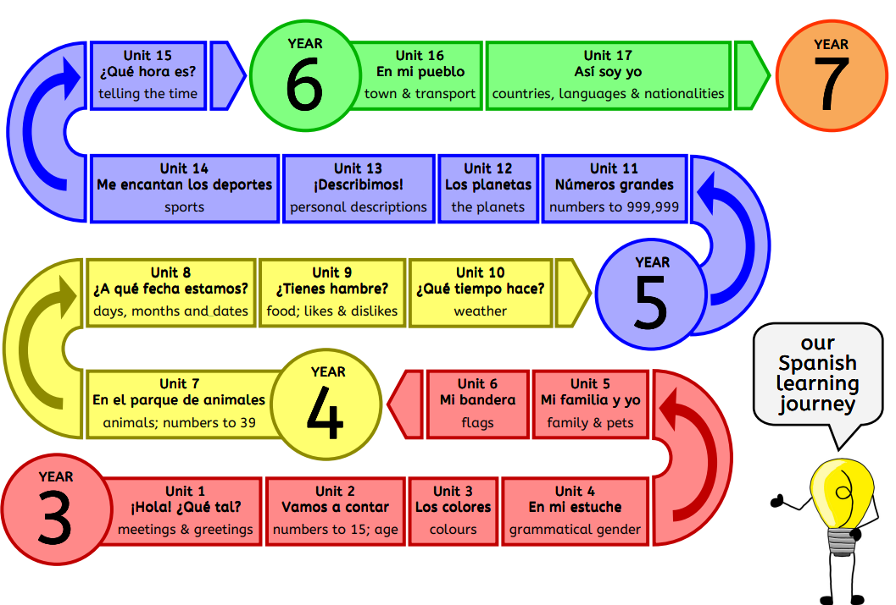

Context, grammar, vocabulary and phonics overview KS2
Term & Unit | Year group | Context | Objectives | I can | Phonics  Grammar | Vocabulary | Planning and video link | Programme of study
Autumn  Unit 1A | Y3 | greetings and saying your name | To greet and say goodbye to another person appropriately  to say what their name is  to ask someone else what their name is | I can  - Greet other people in Spanish and say goodbye  - Tell someone what my name is  - Ask someone what their name is  - Identify boys’ names and girls’ names in Spanish | 1st person me llamo vs 2nd person te llamas  silent h (hola) ll = y (llamo / llamas) a o ñ (español) | Y2 phrases +  hola  ¿cómo te llamas?  Me llamo | Unit 1A plan  https://www.youtube.com/watch?v=nyfLGENmbCE&list=PLgM5QBCeWdkKwe7ebDnU0ZuYZW-MNKFpu&index=2&t=3s | Listening:  - Listen attentively to spoken language and show understanding by joining in and responding - Appreciate stories, songs (poems and rhymes) in the language  - Understand familiar and routine language  Speaking:  - Ask and answer questions  - Engage in conversations  Grammar:  - Key features and patterns of the language (upside down question marks, orthographical accents)  - Conjugation of verbs (me llamo, te llamas)
Autumn  Unit 1B | Y3 | saying how you feel | To say how they feel  To ask someone else how they feel | I can  - Ask someone how they are feeling  - Tell someone how I am feeling  - Take part in a short dialogue with a friend | e  i  u  qu = k | ¿como estas?  ¿qué tal?  estupendo  muy bien  bien  regular  mal  gracias | Unit 1B plan  https://www.youtube.com/watch?v=LgFN_oB25hU&list=PLgM5QBCeWdkKwe7ebDnU0ZuYZW-MNKFpu&index=1&t=107s | Listening:  - Listen attentively to spoken language and show understanding by joining in and responding  - Appreciate stories, songs (poems and rhymes) in the language  - Understand familiar and routine language  - Understand feelings  Speaking:  - Ask and answer questions  - Engage in conversations  - Communicate feelings  Grammar:  - Key features and patterns of the language (upside down question marks, orthographical accents)
Autumn  Unit 2A | Y3 | Numbers to 15 | To count from 0 to 15 reliably | I can  - Count from 0-15  - Use the numbers 0-15 out of sequence | ce / ci / z, b/v, cu  some singular and plural nouns | uno  dos  tres  cuatro  cinco  seis  siete  ocho  nueve  diez  Once  Doce  Trece  Catorce  Quince  número | Unit 2A plan  https://www.youtube.com/watch?v=I6tAHmrsVuA&list=PLgM5QBCeWdkKwe7ebDnU0ZuYZW-MNKFpu&index=14&t=1s | Listening:  - Listen attentively to spoken language and show understanding by joining in and responding  - Appreciate songs and rhymes in the language Speaking:  - Ask and answer questions  - Engage in conversations - Communicate facts Phonics:  - Speak with accurate pronunciation and intonation  - Explore the patterns and sounds of language through songs and rhymes and link the spelling, sound and meaning of words. Writing:  - Write at varying length (words, short phrases)
Autumn  Unit 2B | Y3 | Saying your age | To ask someone how old they are  To say how old they are | I can  - Ask someone how old they are  - Say how old I am  - Take part in a dialogue about age | ce / ci / z, b/v, cu, ñ  tengo / tienes / tiene (persons 1,2,3 of tener to have) | As above +  Años  Cuántos  Tengo  Tienes  ¿Cuántos años tienes? | Unit 2B plan  https://www.youtube.com/watch?v=MLlKa_arxcA&list=PLgM5QBCeWdkKwe7ebDnU0ZuYZW-MNKFpu&index=18&t=22s | Listening:  - Listen attentively to spoken language and show understanding by joining in and responding  - Appreciate stories in the language  - Understand facts - Understand familiar and routine language  Speaking:  - Ask and answer questions  - Engage in conversations  - Communicate facts  Reading:  - Read carefully and show understanding of simple writing  - Appreciate stories in the language  - Develop their ability to understand new words that are introduced into familiar written material  - Understand facts in writing  - Understand writing about familiar and routine matters  Writing:  - Write at varying length (short sentences)  - Adapt phrases to create new sentences  Grammar:  - Key features and patterns of the language (ñ) - tener Language learning skills:  - Explore how the patterns, grammar and words are different from or similar to English (use of tener not verb to be for expressing age)
Spring  Unit 3 | Y3 | using ser to say what colour something is | to say 12 colours in Spanish  to respond to the question ¿Es de qué color?  to use the soy, eres and es forms of the verb ser (to be)  to describe something with colour simply by using de color + colour | I can:  - Say and understand 12 colours  - Write colours correctly  - Use the verb forms soy, eres and es in short descriptive sentences | j, z  1st, 2nd and 3rd persons singular of ser | rojo  azul  verde  amarillo  blanco  negro  rosa  violeta  naranja  marron  gris  soy  color  eres  es  de  que | Unit 3 plan  https://www.youtube.com/watch?v=5n7lWHIqoeA&list=PLgM5QBCeWdkKi_5qMRZI7KGiPoCMTGy0l&index=2 | Listening:  - Listen attentively to spoken language and show understanding by joining in and responding  - Understand facts  Speaking:  - Ask and answer questions  - Engage in conversations  - Communicate facts  Reading:  - Read carefully and show understanding of words  - Understand facts in writing  Writing:  - Write at varying length (words and short sentences)  Grammar: - ser
Spring  Unit 4 | Y3 | Gender of singular nouns using equipment | To say and understand classroom items  To say yes and no  To identify the gender of a noun ending in o or a  To identify the gender of a nouns according to its indefinite article un or una  To use a bilingual dictionary to discover gender and meaning | I can:  - Say and understand 6 classroom objects  - Use the Spanish words for yes and no - Identify the gender of a word by looking at its final letter and/or its indefinite article  - Use a bilingual dictionary to find the meaning of a word and the gender of a word | gender of singular nouns  singular indefinite articles  u z  v vs b | lápiz  veo  bolígrafo  ves  regla  sacapuntas  goma  estuche  un  una | Unit 4 plan  https://www.youtube.com/watch?v=ml2yPSvXpU0&list=PLgM5QBCeWdkKwe7ebDnU0ZuYZW-MNKFpu&index=17  https://www.youtube.com/watch?v=REmPkJO-L-E&list=PLgM5QBCeWdkKwe7ebDnU0ZuYZW-MNKFpu&index=23 | Listening:  - Listen attentively to spoken language and show understanding by joining in and responding (difference between masculine and feminine)  - Appreciate stories in the language  - Understand facts  Speaking:  - Ask and answer questions  - Engage in conversations  Reading:  - Read carefully and show understanding of words  - Appreciate stories in the language  - Develop their ability to understand new words that are introduced into familiar written material  - Understand facts in writing  Writing:  - Write at varying length (short sentences) using the grammatical structures that they have learnt  Grammar:  - Gender of nouns, indefinite articles  - Key feature of the language (gender)  Language learning skills:  - How the patterns and words of the new language are different to English (articles and gender patterns)  - Develop strategies to understand new words, including through using a dictionary
Spring  Unit 5A | Y3 | members of the family, their names and ages | To say and understand family words  To adapt previously learned gender rules to new family words  To say the name of a family member  To say the age of a younger member of the family | I can:  - Say and understand some members of the family  - Say the name of a member of the family  - Say the age of a member of the family | 1st and 3rd person of tener (tengo… años / tiene … años)  1st and 3rd person of llamarse (me llamo / se llama)  possessive adjective mi  silent h ll = y ñ | members of the family  numbers 1-15 ¿Cómo se llama? ¿Cuántos años tiene?  names | Unit 5A plan  https://www.youtube.com/watch?v=vKW6BL8QiY4&list=PLgM5QBCeWdkKi_5qMRZI7KGiPoCMTGy0l&index=13  Saying 6 members of the family and their names (YouTube)  Saying the age of brothers and sisters (YouTube)  https://www.youtube.com/watch?v=yghetcmPKh8&list=PLgM5QBCeWdkKi_5qMRZI7KGiPoCMTGy0l&index=15&t=98s | Listening:  - listen attentively to spoken language and show understanding by joining in and responding  - appreciate stories in the language  - understand facts  Speaking:  - engage in conversations  - communicate facts  Reading:  - read carefully and show understanding of words, phrases and simple writing - appreciate stories in the language  - develop their ability to understand new words that are introduced into familiar written material  - understand facts in writing  Grammar:  - conjugation of high frequency verbs  – ser, tener, llamarse  - gender  Language learning skills:  - how the patterns, grammar and words of the new language are different from or similar to English  – family words, verb llamarse
Summer  Unit 5B | Y3 | pets | To say and understand some pets words  To formulate sentences to say pets’ names and ages  The rules for making nouns plural  To say they have a certain number of pets  To say they don’t have a certain pet | I can:  - Say and understand 9 pet words  - Say what my pet’s name is and how old it is  - Make the pet words plural  - Say the pets I do and don’t have | Gender Rules for making nouns plural 3rd person singular of llamarse and tener to talk about a pet 3rd person plural forms of llamarse and tener to talk about plural pets  Z  J  ll | 9 x pet words numbers 1-15 ¿Cómo se llama(n)? ¿Cuántos años tiene(n)? names | Unit 5B plan  Saying 9 pets, their names and ages (YouTube)  https://www.youtube.com/watch?v=qhWlPZGkv2I&list=PLgM5QBCeWdkKi_5qMRZI7KGiPoCMTGy0l&index=6  https://www.youtube.com/watch?v=CS-6c790vzk&list=PLgM5QBCeWdkKi_5qMRZI7KGiPoCMTGy0l&index=9&t=564s | Listening:  - Listen attentively to spoken language and show understanding by joining in and responding  - Understand facts  Speaking:  - Engage in conversations  - Describe things orally  - Communicate facts  - Speak in sentences, using familiar vocabulary, phrases and basic language structures  - Present ideas and information orally  Reading:  - Read carefully and show understanding of words, phrases and simple writing  - Understand facts in writing  Writing:  - Write at varying length using the variety of grammatical structures they have learned  - Adapt sentences to create new sentences to express ideas clearly  - Describe things in writing  Grammar:  - Gender and number  - Conjugation of high-frequency verbs (tener, llamarse)  Language learning skills:  - How the patterns, grammar and words of the new language are different from or similar to English (pluralisation, negatives, verb forms)
Summer  Unit 6 | Y3 | Recap shape, colour and phrases.  Colours, flags and consolidation of areas | To describe flags using adjectives of colour  To describe flags using shapes | I can:  - Join in with descriptions of flags using colours and shapes  -Use actions to help me to speak accurately  - Say and write what colours a flag has  - Say and write what shapes a flag has | Making the plural form of nouns  Adjectival agreement (feminine singular, describing bandera)  Conjunction y  J  Ci  a | colours  shapes numbers 1-15  bandera | Unit 6 plan  https://www.youtube.com/watch?v=s_uqEfO9xyo&list=PLgM5QBCeWdkKi_5qMRZI7KGiPoCMTGy0l&index=16  https://www.youtube.com/watch?v=3AaJWAEt6sw  https://www.youtube.com/watch?v=TlFwjmeT7tM | Listening:  - Listen attentively to spoken language and show understanding by joining in and responding  Speaking:  - Describe things orally  - Speak in sentences using familiar vocabulary, phrases and basic language structures  - Present ideas orally to a range of audiences (class)  Writing:  - Write at varying length (sentences) using the variety of grammatical structures that they have learned  - Describe things in writing  Grammar:  - Gender and adjectival agreement of feminine singular adjectives  - Conjugation of high frequency verbs (ser / tener) Key features and patterns of the language (need to agree adjectives with their subject)
Autumn  Unit 7A | Y4 | Recap and numbers to 40 | To count from 1 to 39  To understand the new numbers 16-39 and use them out of sequence | I can:  -Count from 1 to 39  -Use the numbers 1 to 39 out of sequence PoS | Conjunction y for joining tens and 1s from 31 to 99  V  Ci  i | Numbers 1-15  Numbers 16-39  Tengo  Tienes  Tiene | Unit 7A plan  https://www.youtube.com/watch?v=xztfcKTiOhw&list=PLgM5QBCeWdkKo2Hdcr1q6aXaI8sRmzs7z&index=4 | Listening:  - Listen attentively to spoken language and show understanding by joining in and responding  Speaking:  - Engage in conversations  - Communicate facts  Writing:  - Write at varying length (phrases) Grammar:  - Key features and patterns of the language  – formation of teens, 20s and 30s Language learning skills:  - How the patterns, grammar and words of the new language are different from or similar to English  – formation of numbers
Autumn  Unit 7B | Y4 | Wild animals and numbers of | To work out the plural form of nouns To say how many of something there is using hay and numbers to 39 | I can:  - Say and use some wild animal words  - Work out the plural forms of some nouns | Making plurals of nouns Using hay Revising the gender of nouns  v, ce/ci/z, i, j, ll, h | Numbers  Wild animals from planning sheet | Unit 7B plan  https://www.youtube.com/watch?v=mg8WnSu90_o&list=PLgM5QBCeWdkKo2Hdcr1q6aXaI8sRmzs7z&index=2  https://www.youtube.com/watch?v=V6e12HeCSts&list=PLgM5QBCeWdkKo2Hdcr1q6aXaI8sRmzs7z&index=7  https://www.youtube.com/watch?v=3gsBFNbsWTQ&list=PLgM5QBCeWdkKo2Hdcr1q6aXaI8sRmzs7z&index=9  https://www.youtube.com/watch?v=eN2d7NRluHU | Listening:  - Listen attentively to spoken language and show understanding by joining in and responding  - Understand facts  Speaking:  - Ask and answer questions  - Engage in conversations  - Communicate facts  - Speak in sentences, using familiar vocabulary, phrases and basic language structures  - Present ideas and information orally Phonics:  - Develop accurate pronunciation and intonation so that others understand then they are reading aloud or using familiar words and phrases  - Speak with accurate pronunciation and intonation  - Link the spelling, sound and meaning of words  Reading:  - Read carefully and show understanding of words, phrases and simple writing  - Understand facts in writing  Writing:  - Write at varying length using the variety of grammatical structures they have learned  - Adapt sentences to create new sentences to express ideas clearly  Grammar:  - Gender  - Hay  - Plural forms Language learning skills: How the patterns, grammar and words of the new language are different from or similar to English
Autumn  Unit 8A | Y4 | Months | To say the 12 months of the year in Spanish  To say the date of their birthday using a number and a month  To say the birthday of a 3rd person, e.g. family member  To say the date of some popular Spanish fiestas and saints’ days | I can:  -Say and understand the months of the year  - Say the dates of some Spanish fiestas  - Ask someone when their birthday is and say when my birthday is  - Say when someone else’s birthday is | Possessive adjectives mi, tu, su  Genitive form el/la…de…  j ñ | 12 months numbers 1-31 cumpleaños  ¿Cuándo es tu cumpleaños?  día / mes | Unit 8A plan  https://www.youtube.com/watch?v=LpG4YrwyBvE&feature=emb_logo  https://www.youtube.com/watch?v=LpG4YrwyBvE&list=PLgM5QBCeWdkKwe7ebDnU0ZuYZW-MNKFpu&index=31  https://www.youtube.com/watch?v=Utt_VxfBbSA&list=PLgM5QBCeWdkKo2Hdcr1q6aXaI8sRmzs7z&index=12 | Listening:  - Listen attentively to spoken language and show understanding by joining in and responding  Speaking:  - Ask and answer questions  - Engage in conversations  Grammar:  - Key features and patterns of the language: month words do not have capital letters  - High-frequency verbs: ser, haber (hay)  Language learning skills:  How the patterns, grammar and words of the new language are different from or similar to English – similarity of the months words
Autumn  Unit 8B | Y4 | Days and dates | To say and understand the days of the week  -To join in with the repeated sections of La Oruga muy hambrienta  - To use a dictionary to find nouns  - To form the plural of nouns • To say and write the date in Spanish | I can:  - Say and understand the days of the week  - Use a bilingual dictionary to help me to adapt a story  - Write the date in Spanish | Plural forms of nouns  j  v  z / ci  a  i | 7 days  12 months numbers 1-31 | Unit 8B plan  https://www.youtube.com/watch?v=87UbcFfZgn8&list=PLgM5QBCeWdkKwe7ebDnU0ZuYZW-MNKFpu&index=32  https://www.youtube.com/watch?v=iqSMTN95bws&list=PLgM5QBCeWdkKo2Hdcr1q6aXaI8sRmzs7z&index=6  https://www.youtube.com/watch?v=TbmhIesCOuQ&list=PLgM5QBCeWdkKo2Hdcr1q6aXaI8sRmzs7z&index=5 | Listening:  - Listen attentively to spoken language and show understanding by joining in and responding  - Appreciate stories and songs in the language  - Understand facts  Speaking:  - Communicate facts and feelings  - Speak in sentences, using familiar vocabulary, phrases and basic language structures  Reading:  - Read carefully and show understanding of words, phrases and simple writing.  - Appreciate stories and songs in the language  - Understand facts in writing  Writing:  - Write at varying length (sentences) using the variety of grammatical structures that they have learned  - Adapt sentences to create new sentences, to express ideas clearly  Grammar:  - Plural nouns  - Key features and patterns of the language – days don’t have capital letters  Language learning skills:  - Develop strategies to understand new words, including through using a dictionary
Spring  Unit 9A | Y4 | opinions of singular foods | To say and understand the names of some singular food and drinks words in  Spanish  Use and understand the difference between the singular indefinite and definite  articles  To give their opinions of singular food and drinks using me encanta, (no) me gusta  and odio  To say they or someone else are hungry and thirsty  To say they or someone else want to eat or drink | I can:  - Say that I am hungry or thirsty and that I want to eat or drink.  - Express my opinions of some foods and drinks. | Expressions with tener (tengo hambre/ tengo sed)  Querer + infinitive  Notion of gender  Definite articles el / la  Opinions of singular foods  Conjunctions y and pero  Qu  H  z | 15 foods/drinks  7 days  hambre/sed  4 opinions comer / beber  ¿te gusta? | Unit 9A plan  Understanding definite and indefintie articles (YouTube)  Saying singular foods and drinks (YouTube)  Giving opinions of singular foods and drinks (YouTube) | Listening:  - Listen attentively to spoken language and show understanding by joining in and responding  - understand feelings  Speaking:  - express opinions  - engage in conversations  - communicate feelings  - speak in sentences, using familiar vocabulary, phrases and basic language structures  Reading:  - develop their ability to understand new words that are introduced into familiar written material  - read carefully and show understanding of words, phrases and simple writing.  - Understand feelings in writing  Writing:  - Write at varying length using the variety of grammatical structures that they have learnt (short paragraph, opinions, articles and connectives)  - Adapt sentences to create new sentences, to express ideas clearly  Grammar:  - Conjugation of high-frequency verbs (gustar, tener, querer)  - Gender and number of nouns  - Definite articles  - Key features and patterns of the language (use of gustar to express opinion)
Spring  Unit 9B | Y4 | opinions of plural foods | To say and understand the names of some plural foods in Spanish  To use and understand the plural definite articles los and las  To give their opinions of singular food and drinks using me encantan, (no) me  gustan and odio  To say they or someone else are hungry and thirsty  To say they or someone else want to eat or drink | I can  - Say that I am hungry or thirsty and that I want to eat or drink.  - Express my opinions of some foods and drinks. | Expressions with tener (tengo hambre/ tengo sed)  Querer + infinitive  Notion of gender  Definite articles el / la /los/las  Opinions of singular and plural foods  Conjunctions y, pero, sin embargo  ci/z, j, a, h, qu | singular foods/drinks  plural foods/drinks Hambre/sed  opinions ¿te gustan? | Unit 9B plan  Saying plural foods and drinks (YouTube)  Giving opinions of plural foods and drinks (YouTube) | Listening:  - Listen attentively to spoken language and show understanding by joining in and responding  - understand feelings  Speaking:  - express opinions  - engage in conversations  - communicate feelings  - speak in sentences, using familiar vocabulary, phrases and basic language structures  Reading:  - develop their ability to understand new words that are introduced into familiar written material  - read carefully and show understanding of words, phrases and simple writing.  - Understand feelings in writing  Writing:  - Write at varying length using the variety of grammatical structures that they have learnt (short paragraph, opinions, articles and connectives)  - Adapt sentences to create new sentences, to express ideas clearly  Grammar:  - Conjugation of high-frequency verbs (gustar, tener, querer)  - Gender and number of nouns  - Definite articles  Key features and patterns of the language (use of gustar to express opinion)
Summer  Unit 10 | Y4 | Weather and compass points | To say 10 weather phrases in Spanish  • To express their opinions of the weather using weather nouns  • To say what the weather is like in different parts of a country, using compass  points  • To say what the weather is like in different towns or cities in Spain | Give my opinions of different kinds of weather  • Say and understand 10 weather phrases  • Say what the weather is like in different parts of a country using points of the compass and town/city names  • Ask what the weather is like  • Give a simple weather forecast  • Find out information about the regions of Spain and their weather | Expressions with tener (tengo calor/frío)  Notion of gender  Notion of number (singular/plural)  Definite articles  H  Ce  Ve  ie | 10 weather nouns  10 weather phrases  compass points  names of towns and cities  ¿Qué tiempo hace? | Unit 10 plan  Saying what the weather is like (YouTube)  Using points of the compass and weather phrases (YouTube)  https://www.youtube.com/watch?v=nA0Jpei9kQw&list=PLgM5QBCeWdkKo2Hdcr1q6aXaI8sRmzs7z&index=14  https://www.youtube.com/watch?v=qXBgSWQboFw&list=PLgM5QBCeWdkKo2Hdcr1q6aXaI8sRmzs7z&index=16 | Listening:  - Listen attentively and show understanding by joining in and responding  - Appreciate songs in the language  - Understand facts  - Understand feelings  Speaking:  - Ask and answer questions  - Engage in conversations  - Communicate facts  - Present ideas and information orally  - Speak with increasing confidence, fluency and spontaneity  - Express opinions  Reading:  - Read carefully and show understanding of words, phrases and simple writing  - Appreciate songs in the language  - Understand facts in writing  Writing:  - Write at varying length (sentences, short paragraph)  - Describe places in writing  Grammar:  - Conjugation of high frequency verbs – hay, hace, está, tener  - Definite articles  - Gender and number of nouns  - Key features and patterns of the language (use of gustar to express opinion)  Language learning skills:  - How the patterns, grammar and words of the new language are different from or similar to English – present tense vs present continuous, use of hace

No. |  |  | Yr |  |  | TITLE |  |  | CONTEXT |  |  | GRAMMAR |  |  |  |  |  |  |  |  |  |  | VOCABULARY |  |  |  | PHONICS
 |  |  |  |  |  |  |  |  |  |  |  |  | • | notion of gender
 |  |  |  |  |  |  |  |  |  |  |  |  | • | notion of number
 | Autumn  11 |  |  | Y5 |  |  | Números grandes |  |  | numbers to 1000 and money |  |  | • | plural forms of nouns |  |  |  |  |  |  |  |  |  | • | numbers to 1000 – counting to 99; counting from 100 to 1000 |  |  | ce / ci, i, qu, v
 | Autumn  11 |  |  | Y5 |  |  | Números grandes |  |  | numbers to 1000 and money |  |  | • |  |  |  |  |  |  |  |  |  |  | • | Euros / céntimos |  |  | ce / ci, i, qu, v
 |  |  |  |  |  |  |  |  |  |  |  |  | • | ser 3 |  |  |  |  |  |  |  |  |  | • | 8 or 9 planets
 | Autumn |  |  |  |  |  |  |  |  |  |  |  | • | indefinite article un |  |  |  |  |  |  |  |  |  | • | 8 adjectives plus 11 colours
 | 12 |  |  | Y5 |  |  | Los planetas |  |  | describing the planets |  |  | • | adjectival position |  |  |  |  |  |  |  |  |  | • | cerca/lejos |  |  | j, qu, ñ, v
 |  |  |  |  |  |  |  |  |  |  |  |  | • | using intensifiers muy / bastante |  |  |  |  |  |  |  |  |  | • | planeta / sol / luna
 |  |  |  |  |  |  |  |  |  |  |  |  | • | conjunction y |  |  |  |  |  |  |  |  |  | • | numbers to 1000
 |  |  |  |  |  |  |  |  |  |  |  |  | • | ser 1, 2, 3
 | Spring |  |  |  |  |  |  |  |  |  |  |  | • | adjectival position
 | 13A |  |  | Y5 |  |  |  |  |  | Personal description |  |  | • | adjectival agreement (fem. sing.) |  |  |  |  |  |  |  |  |  | • | chico/chica |  |  | ge / j, a, o
 | 13A |  |  | Y5 |  |  |  |  |  | Personal description |  |  | • | intensifiers |  |  |  |  |  |  |  |  |  | • | 7 adjectives |  |  | ge / j, a, o
 |  |  |  |  |  |  |  |  |  |  |  |  | • | conjunctions
 |  |  |  |  |  |  |  |  |  |  |  |  | • | making verbs negative with no
 |  |  |  |  |  |  |  |  |  |  |  |  | • | tener 1, 2, 3
 | Spring |  |  |  |  |  | ¡Describimos! |  |  | describing parts of the head and |  |  | • | adjectival agreement |  |  |  |  |  |  |  |  |  | • | 7 part of head (singular and plural) and face, such as the eyes
 | 13B |  |  | Y5 |  |  | ¡Describimos! |  |  | describing parts of the head and |  |  | • | adjectival position |  |  |  |  |  |  |  |  |  | • | Numbers 1-15 |  |  | z, j, ñ
 | 13B |  |  | Y5 |  |  |  |  |  | face |  |  | • | plural of nouns |  |  |  |  |  |  |  |  |  | • | 12 colours |  |  | z, j, ñ
 |  |  |  |  |  |  |  |  |  |  |  |  | • | definite articles |  |  |  |  |  |  |  |  |  | • | 3 hair colours
 |  |  |  |  |  |  |  |  |  |  |  |  | • | notion of gender
 | Spring |  |  |  |  |  |  |  |  |  |  |  | • | tener 3
 | 13C |  |  | Y5 |  |  |  |  |  | describing the bodies of strange |  |  | • | definite articles |  |  |  |  |  |  |  |  |  | • | 30 animals |  |  | j, z, ll, h
 | 13C |  |  | Y5 |  |  |  |  |  | animals |  |  | • | indefinite articles |  |  |  |  |  |  |  |  |  | • | 17 parts of the body |  |  | j, z, ll, h
 |  |  |  |  |  |  |  |  |  |  |  |  | • | genitive form using de
 |  |  |  |  |  |  |  |  |  |  |  |  | • | jugar 1, 2, 3
 |  |  |  |  |  |  |  |  |  |  |  |  | • | hacer 1, 2, 3
 |  |  |  |  |  |  |  |  |  |  |  |  | • | ser 3
 |  |  |  |  |  |  |  |  |  |  |  |  | • | definite articles |  |  |  |  |  |  |  |  |  | • | 27 sports
 |  |  |  |  |  |  | Me encantan los |  |  |  |  |  | • | contraction al |  |  |  |  |  |  |  |  |  | • | 27 sports
 | Summer |  |  |  |  |  | Me encantan los |  |  | talking about sports you do and |  |  | • |  |  |  |  |  |  |  |  |  |  | • | 6 adjectives / adjectival phrases
 | 14 |  |  | Y5 |  |  | Me encantan los |  |  | talking about sports you do and |  |  | • | 1st and 3rd person opinions (singular |  |  |  |  |  |  |  |  |  | • | 6 adjectives / adjectival phrases |  |  | gi / j, ci / ce, h, qu
 | 14 |  |  | Y5 |  |  | deportes |  |  | opinions of them |  |  | • |  |  |  |  |  |  |  |  |  |  | • | 6 opinions |  |  | gi / j, ci / ce, h, qu
 |  |  |  |  |  |  | deportes |  |  | opinions of them |  |  |  | and plural) |  |  |  |  |  |  |  |  |  | • | 6 opinions
 |  |  |  |  |  |  |  |  |  |  |  |  |  |  |  |  |  |  |  |  |  |  |  | • | ¿te gusta?
 |  |  |  |  |  |  |  |  |  |  |  |  | • | conjunction porque + es +adjective |  |  |  |  |  |  |  |  |  | • | ¿te gusta?
 |  |  |  |  |  |  |  |  |  |  |  |  | • | range of conjunctions
 |  |  |  |  |  |  |  |  |  |  |  |  | • | making verbs negative with no /
 |  |  |  |  |  |  |  |  |  |  |  |  |  | no…tampoco
 | Summer |  |  |  |  |  |  |  |  |  |  |  |  |  |  |  |  |  |  |  |  |  |  | • | numbers 1-12
 | 15 |  |  | Y5 |  |  | ¿Qué hora es? |  |  | telling the time |  |  |  |  |  |  |  |  |  |  |  |  |  | • | cuarto/media
 | 15 |  |  | Y5 |  |  | ¿Qué hora es? |  |  | telling the time |  |  | • | ser 3, 6 |  |  |  |  |  |  |  |  |  | • | cuarto/media
 | 15 |  |  | Y5 |  |  | ¿Qué hora es? |  |  | telling the time |  |  | • |  |  |  |  |  |  |  |  |  |  | • | y/menos
 |  |  |  |  |  |  |  |  |  |  |  |  |  |  |  |  |  |  |  |  |  |  |  | • | mediodía/medianoche

 |  |  |  |  |  |  |  |  |  |  |  |  |  |  |  |  |  |  |  |  | • | ¿Qué hora es?
 |  |  |  |  |  |  |  |  |  |  |  |  | • | hay / no hay
 |  |  |  |  |  |  |  |  |  |  |  |  | • | ser 3
 |  |  |  |  |  |  |  |  |  |  |  |  | • | adjectival agreement
 | Autumn  16A |  |  | Y6 |  |  |  |  |  | describing a town and saying what |  |  | • | adjectival position |  |  |  |  |  |  | • | 19 places in town |  |  | h, ce / ci / z, qu, ñ, v
 | Autumn  16A |  |  | Y6 |  |  |  |  |  | describing a town and saying what |  |  | • | intensifiers |  |  |  |  |  |  | • | 16 adjectives |  |  | h, ce / ci / z, qu, ñ, v
 | Autumn  16A |  |  | Y6 |  |  |  |  |  | is there |  |  | • |  |  |  |  |  |  |  | • | 16 adjectives |  |  | h, ce / ci / z, qu, ñ, v
 |  |  |  |  |  |  |  |  |  | is there |  |  | • | definite articles |  |  |  |  |  |  | • | pueblo / ciudad
 |  |  |  |  |  |  |  |  |  |  |  |  | • | indefinite articles
 |  |  |  |  |  |  |  |  |  |  |  |  | • | making verbs negative with no
 |  |  |  |  |  |  | En mi pueblo |  |  |  |  |  | • | range of conjunctions
 |  |  |  |  |  |  |  |  |  |  |  |  | • | infinitives
 | Autumn  16B |  |  | Y6 |  |  |  |  |  | saying what you can do in a town |  |  | • | se puede |  |  |  |  |  |  | • | 19 places in town |  |  | gi, ce/ci/z, h, j, v
 | Autumn  16B |  |  | Y6 |  |  |  |  |  | saying what you can do in a town |  |  | • | hay / no hay |  |  |  |  |  |  | • | 14 infinitives |  |  | gi, ce/ci/z, h, j, v
 |  |  |  |  |  |  |  |  |  |  |  |  | • | making verbs negative with no |  |  |  |  |  |  | • | pueblo / ciudad
 |  |  |  |  |  |  |  |  |  |  |  |  | • | indefinite articles
 | Autumn  16C |  |  | Y6 |  |  |  |  |  | transports and the verb to go |  |  | • | ir 1-6 |  |  |  |  |  |  | • | 19 places in town |  |  | v, h, ci, ll
 | Autumn  16C |  |  | Y6 |  |  |  |  |  | transports and the verb to go |  |  | • | en / a + transport |  |  |  |  |  |  | • | 19 places in town |  |  | v, h, ci, ll
 | Autumn  16C |  |  | Y6 |  |  |  |  |  | transports and the verb to go |  |  | • |  |  |  |  |  |  |  | • | 10 transports |  |  | v, h, ci, ll
 |  |  |  |  |  |  |  |  |  |  |  |  | • | a + el contraction |  |  |  |  |  |  | • | 10 transports
 |  |  |  |  |  |  |  |  |  |  |  |  | • | ser 1-6
 |  |  |  |  |  |  |  |  |  |  |  |  | • | hablar 1-6
 |  |  |  |  |  |  |  |  |  |  |  |  | • | tener 1-6
 |  |  |  |  |  |  |  |  |  |  |  |  | • | vivir 1-6 |  |  |  |  |  |  | • | 15 countries
 | Spring  17 |  |  | Y6 |  |  | Así soy yo |  |  | talking about countries, languages |  |  | • | opinions |  |  |  |  |  |  | • | 15 adjectives |  |  | h, v, ñ, ce/ci, j
 | Spring  17 |  |  | Y6 |  |  | Así soy yo |  |  | talking about countries, languages |  |  | • | infintives |  |  |  |  |  |  | • | 15 languages |  |  | h, v, ñ, ce/ci, j
 | Spring  17 |  |  | Y6 |  |  | Así soy yo |  |  | and nationality |  |  | • |  |  |  |  |  |  |  | • | 15 languages |  |  | h, v, ñ, ce/ci, j
 |  |  |  |  |  |  |  |  |  | and nationality |  |  | • | adjectival agreement |  |  |  |  |  |  | • | 6 opinions
 |  |  |  |  |  |  |  |  |  |  |  |  | • | range of conjunctions |  |  |  |  |  |  | • | 6 infinitives
 |  |  |  |  |  |  |  |  |  |  |  |  | • | use of conjunction porque +es+
 |  |  |  |  |  |  |  |  |  |  |  |  |  | adjective
 |  |  |  |  |  |  |  |  |  |  |  |  | • | use of no to make verbs negative
 |  |  |  |  |  |  |  |  |  |  |  |  | • | adjectival agreement |  |  |  |  |  |  | • | 8 genres of music
 |  |  |  |  |  |  |  |  |  |  |  |  | • | adjectival position |  |  |  |  |  |  | • | 8 genres of music
 | Spring  18A |  |  | - |  |  |  |  |  | giving opinions of genres of music |  |  | • |  |  |  |  |  |  |  | • | 21 adjectives |  |  | ñ, qu
 | Spring  18A |  |  | - |  |  |  |  |  | giving opinions of genres of music |  |  | • | opinions |  |  |  |  |  |  | • | 21 adjectives |  |  | ñ, qu
 | Spring  18A |  |  | - |  |  |  |  |  | giving opinions of genres of music |  |  | • |  |  |  |  |  |  |  | • | 5 opinions |  |  | ñ, qu
 |  |  |  |  |  |  | Yo soy músico |  |  |  |  |  | • | use of conjunction porque +es+ |  |  |  |  |  |  | • | 5 opinions
 |  |  |  |  |  |  | Yo soy músico |  |  |  |  |  | • |  |  |  |  |  |  |  | • | música
 |  |  |  |  |  |  | Yo soy músico |  |  |  |  |  |  | adjective |  |  |  |  |  |  | • | música
 | Summer |  |  |  |  |  |  |  |  |  |  |  | • | tocar 1-6
 | 18B |  |  | - |  |  |  |  |  | saying what instrument you play |  |  | • | other AR verbs |  |  |  |  |  |  | • | 27 instruments |  |  | ll, v, ñ
 |  |  |  |  |  |  |  |  |  |  |  |  | • | definite articles

